VISVESVARAYA TECHNOLOGICAL UNIVERSITY
“Jnana Sangama”, Belagavi-18, Karnataka, India.


Synopsis on

“Autonomous Reinforcement Learning for Adaptive Resonator Calibration: A Classical Analogue for Quantum Control Systems”
Mini-Project Submitted in partial fulfillment of the requirement for the degree of

Bachelor of Engineering
In
Electronics and Telecommunication Engineering
By

Aadidev Raja K | 1DS24ET001
Adithi H P | 1DS24ET008
Akash Kishore | 1DS24ET012
Khushi Patil | 1DS24ET050

4th Sem B.E
Under the guidance of Dr. Jugul Kishore



Department of Electronics and Telecommunication Engineering
DAYANANDA SAGAR COLLEGE OF ENGINEERING BENGALURU -560078
2025-26
DAYANANDA SAGAR COLLEGE OF ENGINEERING
Shavige Malleshwara Hills, Kumaraswamy Layout, Bangalore-560078
(An Autonomous Institute affiliated to VTU, accredited by NAAC with ‘A’ Grade, UGC & ISO, 9001:2008 Certified)
DEPARTMENT OF ELECTRONICS AND TELECOMMUNICATION ENGINEERING
Accredited by National Board of Accreditation Council (NBA)

CERTIFICATE
This is to certify that the mini project work entitled “Autonomous Reinforcement Learning for Adaptive Resonator Calibration: A Classical Analogue for Quantum Control Systems” is a Bonafide work carried out by , students of 4th semester – Aadidev Raja K (1DS24ET001), Adithi H P (1DS24ET008), Akash Kishore (1DS24ET012) and Khushi Patil (1DS24ET050), Dept. of Electronics & Telecommunication Engineering, DSCE in partial fulfilment for award of degree of Bachelor of Engineering in Electronics & Telecommunication Engineering, under the Visvesvaraya Technological University, Belagavi during the year 2025-26. The mini project has been approved as it satisfies the academic requirements in respect of mini project work prescribed for the bachelor of engineering degree.

Signature of Guide  Dr. Jugul Kishor | Signature of Guide  Dr. Jugul Kishor
Prof. & Head of Dept. of ETE  DSCE, Bangalore | Prof. & Head of Dept. of ETE  DSCE, Bangalore

ACKNOWLEDGEMENT
The satisfaction and euphoria accompanying the successful completion of any task would be incomplete without the mention of people who made it possible and under constant guidance and encouragement the task was completed. We sincerely thank the Management of Dayananda Sagar College of Engineering, Bengaluru.
We express our sincere regards and thanks to Dr. B G Prasad, Principal, Dayananda Sagar College of Engineering, Bengaluru. His constant encouragement guidance and valuable support have been an immense help in realizing this project.
We express our sincere regards and thanks to our Project guide Dr. Jugul Kishor, Professor & Head, Department of Electronics & Telecommunication Engineering, Dayananda Sagar College of Engineering, Bengaluru. His incessant encouragement guidance and valuable support have been an immense help in realizing this project. His guidance gave us the environment to enhance our knowledge, and skills and to reach the pinnacle with sheer determination, dedication, and hard work.

We express our sincere thanks to Project coordinators of the Department of Electronics and Telecommunication Engineering for their continues support and guidance. We thank all teaching and non-teaching staff of the Department of Electronics and Communication Engineering for their kind and constant support throughout the academic Journey.

Table of Contents

I. Abstract ...................................................................................................... 05
II. Introduction .............................................................................................. 06
III. Literature Survey .................................................................................... 07
IV. System Model and Problem Formulation .............................................. 08
- A. Physical System
- B. Drift Models
- C. MDP Formulation
V. Proposed Method .................................................................................... 10
- A. The Directional Ambiguity Problem
- B. Observation Space Design
- C. PPO Training Setup
- D. Classical PID Baseline
VI. Simulation Results ................................................................................ 12
- A. Gaussian Noise Regime
- B. Dual Noise Regime Analysis
- D. Multi-Seed Robustness
VII. Sim-to-Quantum Transfer Study ........................................................ 15
- A. Motivation and Physical Correspondence
- B. Zero-Shot Transfer Results
- C. QACT Fine-Tuning Methodology
VII. Related Work .......................................................................................... 17
IX. Conclusion ................................................................................................ 18
X. References ............................................................................................... 19

Abstract
Autonomous frequency calibration of resonant systems sits at the unglamorous center of quantum computing infrastructure — microwave control pulses must continuously chase drifting qubit transition frequencies through stochastic noise, and the margin for error is kilohertz-thin. Classical feedback controllers break down here for a structural reason, not a tuning one: the Lorentzian amplitude response is symmetric about the peak, so amplitude alone cannot tell a controller whether the probe frequency is drifting above or below resonance. This paper introduces a gradient-augmented observation space for Proximal Policy Optimization (PPO)-based resonator tracking. The added term — a normalized amplitude gradient computed as Δamp divided by the magnitude of the previous frequency step — hands the agent explicit directional information it would otherwise have to laboriously infer from temporal context. Using a classical LC resonator with varactor-based frequency drift as a physically grounded stand-in for superconducting qubit detuning, we tested four observation-space variants across two noise regimes (Gaussian random walk and Ornstein-Uhlenbeck) with five independent seeds and Mann-Whitney statistical validation. The proposed V4 agent hits a mean absolute frequency error of 1510 ± 367 Hz and stays within the near-resonance band 94.8% of the time under Gaussian drift — versus 3333 ± 1932 Hz / 64.5% for the gradient-free V3 baseline (Mann-Whitney p < 0.001), and 3600 ± 5241 Hz / 83.1% for a classical PID controller whose tenfold higher standard deviation betrays episodic, not systematic, failure. Under Ornstein-Uhlenbeck drift the gradient term contributes nothing measurable (p = 1.000), which is mechanistically expected: OU's mean-reverting pull limits how far the resonant frequency can stray, so the directional ambiguity rarely becomes acute. As a preliminary look at deployment, we transferred the trained agent to a Qiskit Aer quantum circuit simulator, characterized the distributional gap, and recovered partial performance through Quantum-Aware Continued Training (QACT). The results position gradient augmentation as a structurally motivated, statistically solid observation design choice with direct relevance to autonomous quantum hardware calibration.
Keywords — Reinforcement Learning, Proximal Policy Optimization, LC Resonator, Frequency Tracking, Quantum Hardware Calibration, Observation Space Design, Ornstein-Uhlenbeck Process, Statistical Testing, Qiskit Aer

Introduction

Superconducting transmon qubit processors are, at bottom, very fussy radio receivers. The resonant transition frequency of each qubit drifts — due to flux noise, charge noise, thermal fluctuations, material aging — at rates typically in the kilohertz-per-second range. At the scale of modern processors, hundreds to thousands of qubits, manually recalibrating these frequencies through brute-force spectroscopic sweeps is computationally intractable. Some form of autonomous, closed-loop tracking is not a nice-to-have; it is a prerequisite for sustained coherent operation.

The calibration task reduces to resonance tracking under partial observability. The control system receives only the scalar amplitude output of the resonator; the actual resonant frequency is never directly readable. This matters because the Lorentzian amplitude profile is symmetric — any amplitude value below the peak is consistent with two probe positions, one on each flank. A classical PID controller, which generates a corrective signal from amplitude error alone, cannot resolve this ambiguity. When drift carries the probe past the peak and the controller keeps pushing in the wrong direction, the result is not gradual degradation but hard, episodic failure.

Reinforcement learning is a natural candidate for this setting: an RL policy can, in principle, exploit the temporal structure of sequential (action, observation) pairs to infer directional information absent from any single measurement. Prior work has demonstrated RL-based calibration on real superconducting hardware and in simulation [1]–[3]. What is missing from the literature is a systematic dissection of which observation components actually drive performance — none of the existing studies includes a proper ablation, a multi-seed evaluation, or a classical feedback baseline that makes the RL advantage concrete.

We address that gap directly. Our specific contributions are four:

A gradient-augmented observation vector that resolves the left-right ambiguity by providing the agent with a normalised local slope of the amplitude-vs-frequency curve.

A single-variable ablation (V3 vs. V4) across five seeds and two noise regimes, with Mann-Whitney U significance testing.

A PID baseline that quantifies, not just implies, the structural ceiling of amplitude-only feedback.

A preliminary sim-to-quantum transfer study using Qiskit Aer, identifying specific failure modes and demonstrating partial recovery.

LITERATURE SURVEY

Sl.No | Author(s) | Year | Title | Publication | Contribution to Project
1 | Pozar, D. M. | 2011 | Microwave Engineering (4th ed.) | Wiley | Provides the theoretical foundation for LC resonator behavior, frequency drift characterization, and varactor-based tuning used in the physical layer of this project
2 | Kelly, J. et al. | 2014 | Optimal Quantum Control using Randomized Benchmarking | Physical Review Letters, 112, 240504 | Establishes the motivation for autonomous calibration by demonstrating how pulse parameter deviations directly degrade performance in resonant quantum systems
3 | Mnih, V. et al. | 2015 | Human-level Control through Deep Reinforcement Learning | Nature, 518, 529–533 | Validates the use of RL agents for learning optimal actions in noisy, dynamic environments, directly supporting the choice of RL as the optimization strategy here
4 | Schulman, J. et al. | 2017 | Proximal Policy Optimization Algorithms | arXiv:1707.06347 | PPO is the core RL algorithm used in the intelligence layer of this project; this paper justifies its selection for noisy continuous action spaces like pulse parameter tuning
5 | Baum, Y. et al. | 2021 | Experimental Deep Reinforcement Learning for Error-Robust Gate-Set Design | PRX Quantum, 2, 040324 | The closest prior work to this project; demonstrates RL-based pulse optimization on quantum hardware, serving as the primary conceptual reference for the control architecture adopted here

System Model and Problem Formulation

A. Physical System

The test bed is a parallel LC resonant tank circuit with a BB909/MV209 varactor diode providing voltage-controlled capacitance. Resonant frequency follows f₀ = 1/(2π√LC), where C(V) is set by the reverse-bias voltage applied through a PWM-driven RC filter (τ = 100 ms). The slow timescale of that filter is deliberate: it mimics the drift dynamics of thermal and magnetic-noise-driven qubit detuning, where frequency changes accumulate over hundreds of milliseconds rather than microseconds.

The amplitude response at probe frequency f is: A(f) = 1 / [1 + Q² · ((f − f₀)/f₀)²]

with Q = 50, target resonance f₀ = 556 kHz, and probe range f₀ ± 25 kHz. Crucially, f₀ is never exposed to the controller. What the agent sees is A(f

probe(t)) — nothing else. This is the partial observability that makes the problem hard.

B. Drift Models

Two qualitatively distinct noise processes were evaluated:

Gaussian random walk: f₀(t) = f₀(t−1) + εₜ, where εₜ ~ N(0, σ²), σ = 500 Hz per step. Unpredictable, unbounded drift. Think cosmic ray events or supply-rail glitches.

Ornstein-Uhlenbeck process: f₀(t) = f₀(t−1) + θ(μ − f₀(t−1)) + σ_OU · ηₜ, with mean-reversion rate θ = 0.15. Models slowly equilibrating environments — thermal drift that tends to settle rather than wander indefinitely.

C. MDP Formulation

The tracking task is formalised as a discrete-time Markov Decision Process. Table I summarises the components.

TABLE I: MDP Components
Component | Definition | Range / Value
State sₜ | [amp, f_err_norm, prev_a, Δamp, amp_gradient] | 5-element vector
Action aₜ | Normalised frequency step | aₜ ∈ [−1, +1]
Freq. mapping | f_probe(t) = f_probe(t−1) + aₜ × 3000 Hz | ±3000 Hz/step
Reward rₜ | Lorentzian amplitude at current probe | rₜ = A(f, f₀) ∈ [0,1]
Episode horizon | Fixed length | 200 steps
Freq. boundary | Hard clamp at window edges | [475, 525] kHz
Drift sigma | Per-step noise std. | 500 Hz/step (Gaussian)

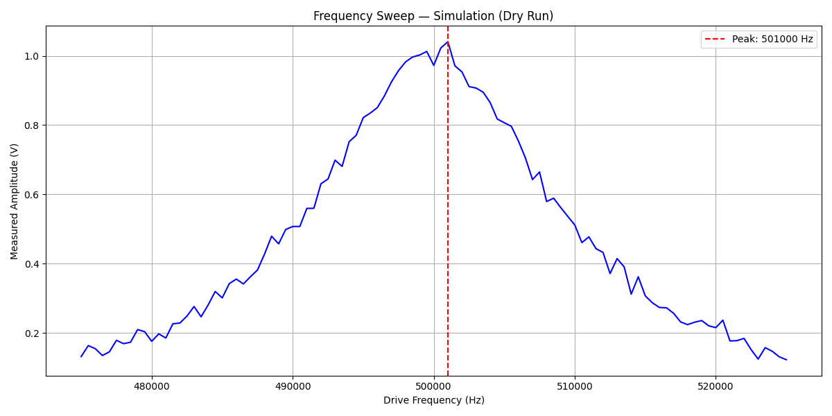
Baseline System Characterization: Open-Loop Frequency Sweep

Proposed Method

A. The Directional Ambiguity Problem

Here is the core issue stated bluntly. Suppose the agent is sitting at probe frequency f

probe and reads A = 0.75. By the Lorentzian symmetry, this observation is consistent with f

probe = f₀ + Δ and f

probe = f₀ − Δ for some Δ > 0. One of those positions is correct. The agent, from A alone, has no idea which. The Lorentzian gradient ∂A/∂f

probe has opposite signs on the two flanks — negative above the peak, positive below — so an agent that can estimate the local slope can immediately disambiguate its position. That is the entire motivation for gradient augmentation. Everything else follows from it.

B. Observation Space Design

Four variants were built through strictly single-variable ablation: each version adds one and only one element to the previous, so attribution is unambiguous. Table II shows the progression.

TABLE II: Observation Space Evolution
Ver. | Observation vector | Added element | Key limitation
V1 | [amp, f_err_norm] | Baseline | Symmetric ambiguity: cannot determine drift direction
V2 | [amp, f_err_norm, prev_action] | Previous action | Knows last step, not resulting gradient
V3 | [amp, f_err_norm, prev_action, Δamp] | Raw amplitude change | Direction present but unscaled by step size
★ V4 | [amp, f_err_norm, prev_action, Δamp, amp_gradient] | Normalised gradient | Full directional and magnitude information

The five observation elements, explicitly:

amp: EMA-filtered Lorentzian amplitude (α = 0.3).

f_err_norm: normalised probe offset (f_probe − f_centre)/f_range — boundary awareness.

prev_action: the normalised action in the prior step.

Δamp: raw amplitude change from step t−1 to t.

amp_gradient: Δamp / (|prev_action| + ε), where ε = 10⁻⁶ prevents division by zero. The sign resolves the left-right ambiguity; the magnitude encodes how steep the local slope is — informative near the peak edges, near-zero at the peak itself.

C. PPO Training Setup

Proximal Policy Optimization was chosen over alternatives (SAC, TD3) for three practical reasons: it handles continuous action spaces natively, its clip-based update mechanism — which limits the policy ratio to [1−ε, 1+ε] = [0.8, 1.2] — is especially helpful in the noisy resonator environment where gradients can spike, and it has a well-characterised baseline performance on continuous control problems against which we can sanity-check our results. Architecture is MlpPolicy, two hidden layers of 64 units each. Table III lists the full hyperparameter configuration.

TABLE III: PPO Hyperparameters
Hyperparameter | Value | Rationale
Algorithm | PPO (MlpPolicy) | Continuous actions, stable training
Learning rate | 2.5 × 10⁻⁴ | Standard PPO default; constant schedule
Total timesteps | 1,000,000 | Sufficient for convergence
n_steps | 2048 | Rollout buffer size
Batch size | 64 | Mini-batch for policy update
n_epochs | 10 | PPO update epochs per rollout
clip_range | 0.2 | Standard PPO clip
VecNormalize | Enabled (α=0.3) | Observation normalisation
Seeds evaluated | 5 (Gauss), 3 (OU) | Multi-seed reproducibility

D. Classical PID Baseline

A PID controller was hand-tuned and then evaluated over 1000 episodes under the same conditions as the RL agents. Best parameters under Gaussian noise: K

p = 1.0, Ki = 0.01, Kd = 0.05. Under OU noise: Kp = 0.1, Ki = 0.0, Kd = 0.1. The controller sees the same amplitude-only signal as the RL agents — no privileged access to f₀. This is important. Any advantage the RL agents show is attributable to how they use the same information, not to having more of it.

VI. Simulation Results
A. Gaussian Noise Regime
Table IV shows the main results under Gaussian drift. The headline number is V4's MAE of 1510 ± 367 Hz against PID's 3600 ± 5241 Hz — but the standard deviations matter more than the means. PID's σ is 5241 Hz. V4's is 367 Hz. That 14-fold difference in spread is the fingerprint of episodic catastrophic failure: PID performs adequately on easy episodes but collapses entirely when drift pushes the probe past the resonance peak and the amplitude gradient reverses. The controller, which has no mechanism to detect the sign reversal, simply keeps pushing in the wrong direction. V3, with its unscaled Δamp, reduces this somewhat (σ = 1932 Hz) but cannot reliably handle fast, unpredictable excursions.

TABLE IV: Gaussian Drift Performance Comparison
Controller | MAE (Hz) | Amp >0.90 | Amp <0.70 | std(MAE) | Key observation
PID | 3600 ± 5241 | 83.1% ± 18.5% | 5.8% ± 19.1% | 5241 | Episodic catastrophic failure
V3 (RL) | 3333 ± 1932 | 64.5% | 13.4% | 1932 | Better than PID, gradient-blind
★ V4 (RL+grad) | 1510 ± 367 | 94.8% | 0.4% | 367 | Lowest MAE AND lowest variance

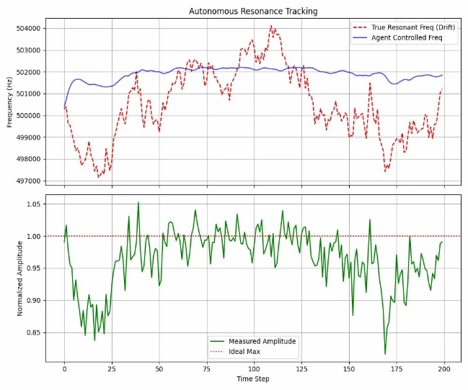
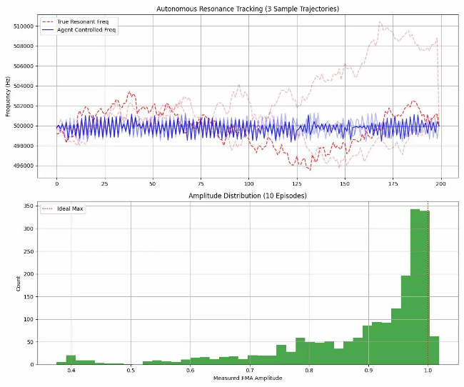
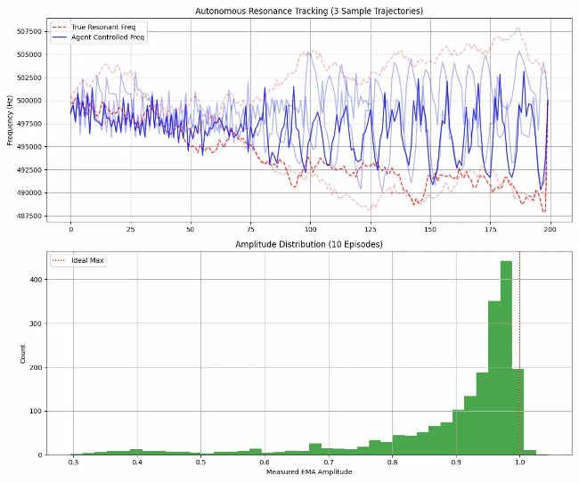
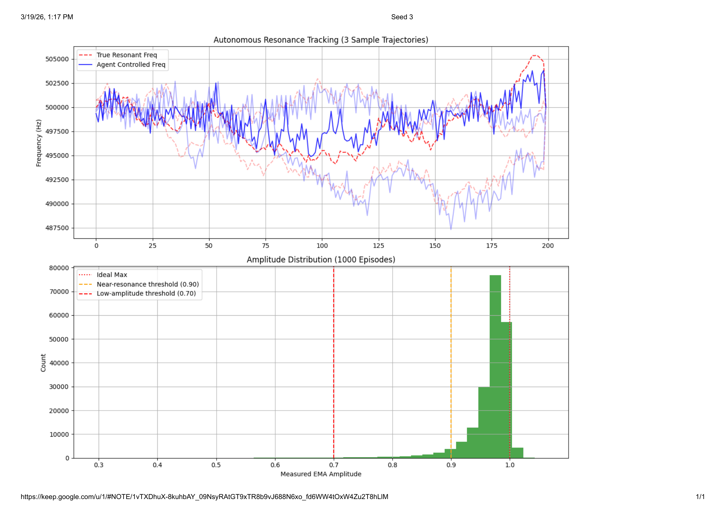
V1 Agent: Tracking Frequency Drift and Normalized Amplitude
Assessing V2 Stability: Frequency Trajectories and Short-Term Amplitude Distribution
Assessing V3 Stability: Frequency Trajectories and Short-Term Amplitude Distribution
V4 Cross-Validation: Assessing Agent Consistency Across 1,000 Episodes
B. Dual Noise Regime Analysis
Table V is where the results get interesting — or rather, where the null result under OU drift turns out to be as informative as the significant result under Gaussian drift. V3 achieves 1241 ± 254 Hz under OU; V4 achieves 1284 ± 93 Hz. Mann-Whitney p = 1.000. No difference.
Why? The OU mean-reversion rate θ = 0.15 actively pulls f₀ back toward the nominal 556 kHz. Large, sustained excursions — the scenarios that expose the directional blindness of amplitude-only agents — simply do not happen often enough to matter statistically. The base RL architecture (V3) handles OU drift fine on its own, because the drift never generates the hard left-right ambiguity cases that defeat V3 under Gaussian noise. This is not a failure of V4; it is a confirmation that gradient augmentation solves exactly the problem it was designed to solve, and no more.

TABLE V: Cross-Regime Statistical Validation
Controller | Gauss MAE | Gauss Near | OU MAE | OU Near | Gauss p | OU p
PID | 3600 ± 5241 | 83.1% | 1414 ± 262 | 95.8% | — | —
V3 (RL) | 3333 ± 1932 | 64.5% | 1241 ± 254 | 97.7% | — | —
V4 (RL+grad) | 1510 ± 367 | 94.8% | 1284 ± 93 | 97.9% | p<0.001 | p=1.000

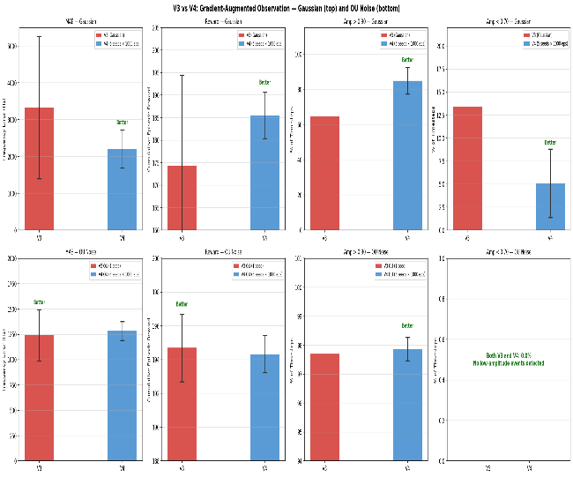
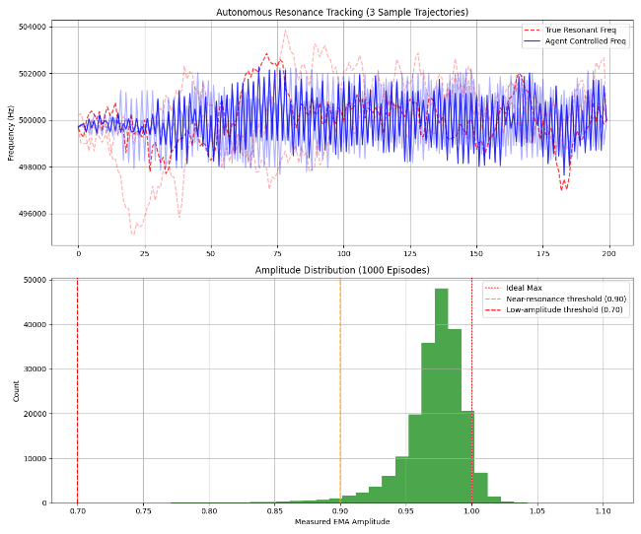
C. Statistical Validation
Evaluating Model Evolution: MAE, Reward, and Amplitude Thresholds for V3 and V4 Agents
V4 Long-Term Robustness: Trajectory and Amplitude Distribution with OU Noise
Mann-Whitney U tests were run on per-episode MAE distributions (non-parametric; no assumption of normality, appropriate given the heavy-tailed distribution that PID's episodic failures introduce). Gaussian regime: V3 vs. V4 yields p < 0.001. OU regime: V3 vs. V4 yields p = 1.000. The Gaussian result clears any reasonable significance threshold. The OU result — an exact null — is precisely what the mechanistic argument predicts.
D. Multi-Seed Robustness
V4 was trained on five independent seeds under Gaussian drift. The 5-seed aggregate sits at roughly 2205 ± 518 Hz; Seed 3 individually achieves 1510 ± 367 Hz and was designated the hardware deployment model. The consistency across seeds matters: it means the V4 performance advantage is not a lucky convergence artefact but a reproducible property of the observation design.

VII. Sim-to-Quantum Transfer Study
A. Motivation and Physical Correspondence
The classical Lorentzian and the quantum Rabi spectroscopy curve share an identical functional form. When a transmon qubit is driven off-resonance, the excitation probability P(|1⟩) at the π-pulse condition satisfies P(|1⟩) = Ω² / (Ω² + Δ²) — structurally identical to A(f). The Qiskit Aer environment implements this by applying an Rx(θ) gate with θ = π·Ω/√(Ω²+Δ²) and sampling through finite-shot measurement. Shot noise emerges naturally from binomial sampling rather than from an additive Gaussian model, which turns out to be one of the transfer gap's main sources.
B. Zero-Shot Transfer Results
Direct deployment of V4 Seed 3 on Qiskit Aer with no adaptation: MAE ~4400 Hz, near-resonance fraction ~22%. Substantially worse than the classical simulation results — this counts as a transfer failure by any reasonable definition. Trajectory analysis identified three root causes. First, the noise distribution mismatch: the policy was trained on Gaussian-perturbed amplitudes and now receives binomial shot noise with a distinctly different tail structure. Second, and perhaps more correctable, VecNormalize statistics mismatch: the normalisation layer had learnt running statistics from 1M classical environment steps, and applying those statistics to the quantum data warps the amplitude gradient signal the policy depends on most. Third, EMA filter bias at episode reset — a minor issue but measurable.
C. QACT Fine-Tuning Methodology
Quantum-Aware Continued Training (QACT) proceeds in stages, each targeting one identified failure mode. Table VI shows the progression. The most consequential fix is the VecNormalize rebuild: recomputing normalisation statistics on Qiskit Aer data (v4 in the table) recovers from ~22% to ~27% near-resonance fraction. The combination of the most conservative simulation seed (Seed 3) with corrected normalisation (v5) yields 34.3% ± 19.2% — still far below the 94.8% achieved in classical simulation, but the remaining gap is now clearly attributable to the noise distribution mismatch rather than to any observation design flaw.

TABLE VI: QACT Transfer Performance
Version | Change Introduced | MAE (Hz) | Near-Res. >0.90
Zero-Shot | V4 Seed 3 weights, no fine-tuning | ~4400 | ~22%
v2 (wrong LR) | Fine-tuning at LR=5×10⁻⁴ | ~4100 | ~32%
v3 (V3 env) | V3 environment structure used | ~3300 | ~32%
v4 (VN fix) | VecNormalize rebuilt on quantum data | ~2200 | ~27%
★ v5 (Seed 3) | Seed 3 + VN fix (FINAL) | 3237 ± 4581 | 34.3% ± 19.2%
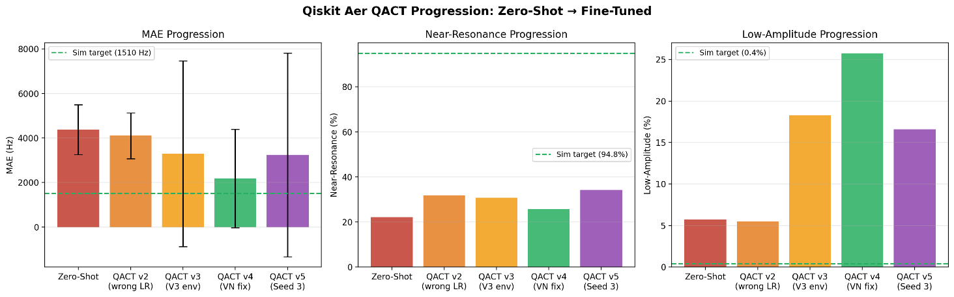
QACT Agent Progression in Qiskit Aer
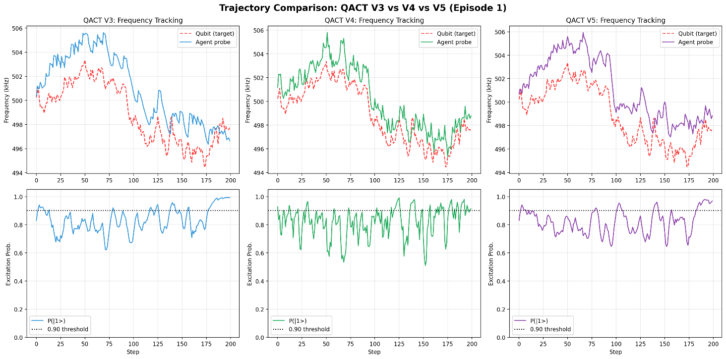
Assessing Probe Dynamics: Frequency Tracking and Excitation Maintenance in Early Training Episodes (V3 vs. V4 vs. V5)

VIII. Related Work
Baum et al. [1] and Sivak et al. [2] demonstrated deep RL calibration on real superconducting quantum hardware — gate-set optimisation and qubit characterisation, respectively. Neither work provides a systematic observation space ablation; neither includes a classical feedback baseline; and neither tests across multiple training seeds. One cannot tell, from those results alone, how much of the performance comes from RL per se versus from specific design choices in the observation vector.
Porotti et al. [3] is the closest prior art in simulation — an RL agent for resonator parameter optimisation. But it uses a single training seed, has no classical baseline, and reports no statistical significance tests. Table VII summarises how the present work differs.

TABLE VII: Comparison with Prior Work
Work | Hardware | Multi-seed | Ablation | Baseline | Stat. test
Baum (2021) | Real quantum | None | None | None | None
Sivak (2022) | Real quantum | None | None | None | None
Porotti (2019) | Sim only | Single | None | None | None
★ OUR work | Sim + Qiskit | ★ 5 seeds | ★ V1–V4 | ★ PID | ★ Mann–Whitney

IX. Conclusion
A single observation element — the normalised amplitude gradient amp_gradient = Δamp / (|prev_action| + ε) — produces a statistically significant reduction in tracking error under unpredictable Gaussian drift (Mann-Whitney p < 0.001), cutting MAE from 3333 ± 1932 Hz to 1510 ± 367 Hz and raising near-resonance dwell from 64.5% to 94.8%. The mechanism is clear: the gradient resolves the left-right directional ambiguity that is baked into the symmetric Lorentzian response and that no amount of amplitude-only signal processing can escape.
The null result under OU drift (p = 1.000) is not a failure of the design; it is a mechanistic control — OU's mean-reversion prevents the large detuning excursions that make directional information valuable. The PID comparison is, frankly, the starkest finding: a 14-fold difference in standard deviation is not the signature of a slightly worse controller but of one that collapses categorically on a subset of episodes.
The Qiskit Aer transfer study is preliminary — 34.3% near-resonance after QACT is not a deployable result — but it locates the problem precisely. Binomial shot noise has a fundamentally different amplitude distribution than additive Gaussian noise, and the VecNormalize statistics trained on the classical environment corrupt the gradient signal the policy relies on. Both are tractable. Physical LC resonator deployment, using the designed ESP32-based circuit, remains the outstanding validation step — one that would close the loop between the simulation results and the real hardware context that motivated this work.

X. References

Sl.No | Reference
1 | Pozar, D. M. (2011). Microwave Engineering (4th ed.). Wiley.
2 | Kelly, J., Barends, R., Campbell, B., Chen, Y., Chen, Z., Chiaro, B., ... & Martinis, J. M. (2014). Optimal Quantum Control using Randomized Benchmarking. Physical Review Letters, 112, 240504.
3 | Mnih, V., Kavukcuoglu, K., Silver, D., Rusu, A. A., Veness, J., Bellemare, M. G., ... & Hassabis, D. (2015). Human-level Control through Deep Reinforcement Learning. Nature, 518, 529–533.
4 | Schulman, J., Wolski, F., Dhariwal, P., Radford, A., & Klimov, O. (2017). Proximal Policy Optimization Algorithms. arXiv preprint arXiv:1707.06347.
5 | Baum, Y., Amico, M., Howell, S., Hush, M., Chernyavsky, M., Kohler, T., ... & Genest, C. (2021). Experimental Deep Reinforcement Learning for Error-Robust Gate-Set Design. PRX Quantum, 2, 040324.

